January
2025
 |  |  |  |  |  | 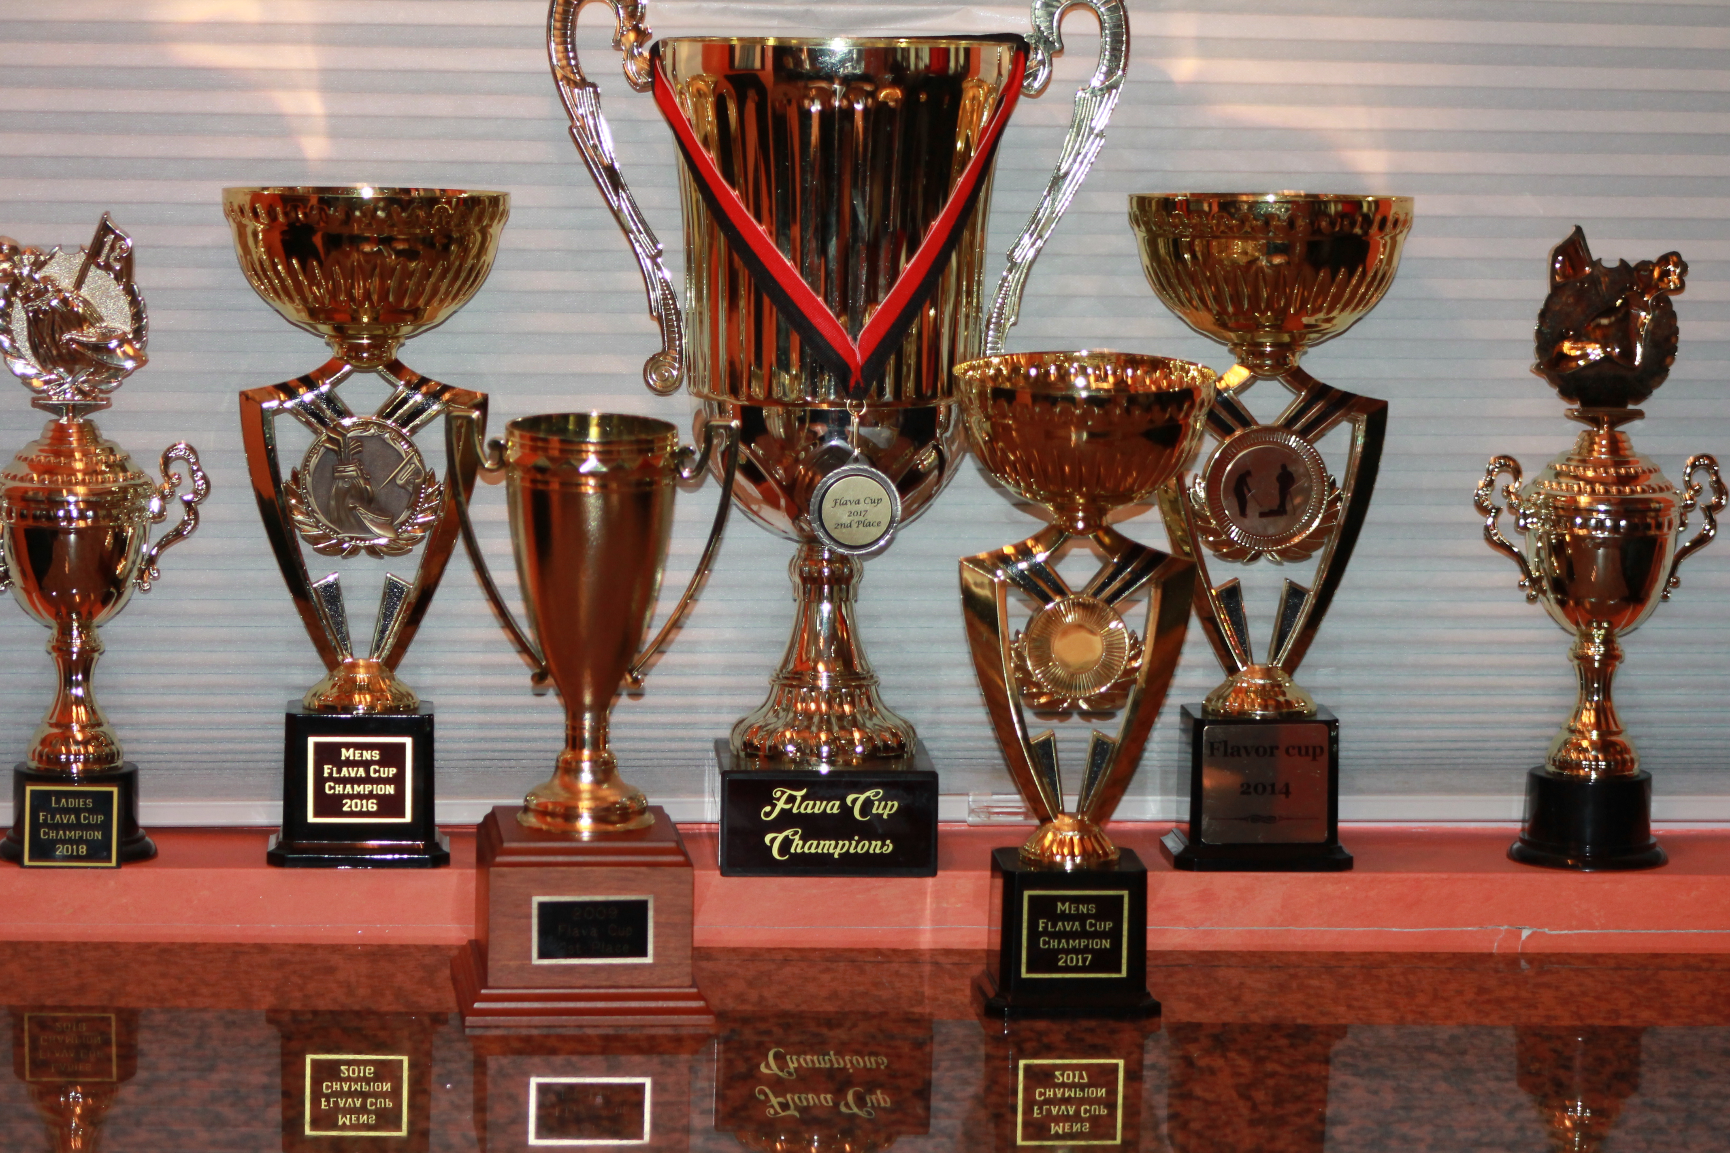
 | W.E.S.T. GOLF CLUB
Sunday |  | Monday | Tuesday | Wednesday | Thursday |  | Friday | Saturday
 |  |  |  | 1 | 2 |  | 3 | 4
 |  |  |  | New Years Day
5 |  | 6 | 7 | 8 | 9 |  | 10 | 11
12 |  | 13 | 14 | 15 | 16 |  | 17 | 18
19 |  | 20 | 21 | 22 | 23 |  | 24 | 25
26 |  | 27 | 28 | 29 | 30 |  | 31
View and edit this document in Word on your computer, tablet, or phone. You can edit text; easily insert content such as pictures, shapes, and tables; and seamlessly save the document to the cloud from Word on your Windows, Mac, Android, or iOS device.

February
2025
 |  |  |  |  |  | 
 | 
Sunday |  | Monday | Tuesday | Wednesday | Thursday |  | Friday | Saturday
 |  |  |  |  |  |  |  | 1
2 |  | 3 | 4 | 5 | 6 |  | 7 | 8
9 |  | 10 | 11 | 12 | 13 |  | 14 | 15
 |  |  |  |  |  |  | Valentines Day
16 |  | 17 | 18 | 19 | 20 |  | 21 | 22
23 |  | 24 | 25 | 26 | 27 |  | 28
View and edit this document in Word on your computer, tablet, or phone. You can edit text; easily insert content such as pictures, shapes, and tables; and seamlessly save the document to the cloud from Word on your Windows, Mac, Android, or iOS device.

March
2025
 |  |  |  |  |  | 
Sunday |  | Monday | Tuesday | Wednesday | Thursday |  | Friday | Saturday
 |  |  |  |  |  |  |  | 1
2 |  | 3 | 4 | 5 | 6 |  | 7 | 8
9 |  | 10 | 11 | 12 | 13 |  | 14 | 15
 |  |  |  |  |  |  | Tampa Tournament | Tampa Tournament
16 |  | 17 | 18 | 19 | 20 |  | 21 | 22
Tampa Tournament |  |  |  |  |  |  |  | Club Meeting  6:00 PM  Avon Fields
23 |  | 24 | 25 | 26 | 27 |  | 28 | 29
30 |  | 31
 |  | Las Vagas Tournament
View and edit this document in Word on your computer, tablet, or phone. You can edit text; easily insert content such as pictures, shapes, and tables; and seamlessly save the document to the cloud from Word on your Windows, Mac, Android, or iOS device.

April
2025
 |  |  |  |  |  | 

W.E.S.T. GOLF CLUB
Our first Club Tournament will be on April 27
Red Shirts
Green - W.E.S.T. Club Tournaments
YELLOW - Out of Town Events
Scrambles
Weekly Games
Holidays

Sunday |  | Monday | Tuesday | Wednesday | Thursday |  | Friday | Saturday
 |  |  | 1 | 2 | 3 |  | 4 | 5
 |  |  | Las Vagas Tournament | Las Vagas Tournament | Las Vagas Tournament |  | Las Vagas Tournament
6 |  | 7 | 8 | 9 | 10 |  | 11 | 12
Mill
12:00 Noon
$48
13 |  | 14 | 15 | 16 | 17 |  | 18 | 19
Fairfield
12:00 Noon
20 |  | 21 | 22 | 23 | 24 |  | 25 | 26
Easter
27 |  | 28 | 29 | 30
Glenview
Club Tournament
12:00 Noon
View and edit this document in Word on your computer, tablet, or phone. You can edit text; easily insert content such as pictures, shapes, and tables; and seamlessly save the document to the cloud from Word on your Windows, Mac, Android, or iOS device.

May
2025
 |  |  |  |  |  | 

W.E.S.T. GOLF CLUB
Green - W.E.S.T. Club Tournaments
YELLOW - Out of Town Events
Scrambles
Weekly Games
Holidays
Sunday |  | Monday | Tuesday | Wednesday | Thursday |  | Friday | Saturday
 |  |  |  |  | 1 |  | 2 | 3
Quinn Chapel
Scramble 1:00 PM
Fairfield
4 |  | 5 | 6 | 7 | 8 |  | 9 | 10
Circling Hills  12:00 Noon |  |  |  |  |  |  |  | Reaching Out For Kids Scramble
11 |  | 12 | 13 | 14 | 15 |  | 16 | 17
Mothers Day |  |  |  |  |  |  | Charlotte Players  3 Day Tournament  16/17/18 | Delta Scramble
18 |  | 19 | 20 | 21 | 22 |  | 23 | 24
Sharon Woods  12:00 Noon |  |  |  | Myrtle Beach  Cobb Group | Myrtle Beach  Cobb Group |  | Myrtle Beach  Cobb Group | Myrtle Beach  Cobb Group
25 |  | 26 | 27 | 28 | 29 |  | 30 | 31
Myrtle Beach  Cobb Group |  | Memorial Day
View and edit this document in Word on your computer, tablet, or phone. You can edit text; easily insert content such as pictures, shapes, and tables; and seamlessly save the document to the cloud from Word on your Windows, Mac, Android, or iOS device.

June
2025
 |  |  |  |  |  | 

W.E.S.T. GOLF CLUB
Green - W.E.S.T. Club Tournaments
YELLOW - Out of Town Events
Scrambles
Weekly Games
Holidays
Sunday |  | Monday | Tuesday | Wednesday | Thursday |  | Friday | Saturday
1 |  | 2 | 3 | 4 | 5 |  | 6 | 7
Walden Pond
Club Tournament
12:00 Noon $56
8 |  | 9 | 10 | 11 | 12 |  | 13 | 14
California  12:00 Noon |  |  |  |  |  |  |  | Pipestone  11:10
15 |  | 16 | 17 | 18 | 19 |  | 20 | 21
Fathers Day |  |  |  |  |  |  | Game Skin Fairfield Greens | W.E.S.T.CLUB TOURNAMENT  1:00 PM
22 |  | 23 | 24 | 25 | 26 |  | 27 | 28
W.E.S.T.CLUB TOURNAMENT 8:00 AM
29 |  | 30
Belterra $70
Club Tournament
12:00 Noon
View and edit this document in Word on your computer, tablet, or phone. You can edit text; easily insert content such as pictures, shapes, and tables; and seamlessly save the document to the cloud from Word on your Windows, Mac, Android, or iOS device.

July
2025
 |  |  |  |  |  | 

W.E.S.T. GOLF CLUB
Green - W.E.S.T. Club Tournaments
YELLOW - Out of Town Events
Scrambles
Weekly Games
Holidays
Sunday |  | Monday | Tuesday | Wednesday | Thursday |  | Friday | Saturday
 |  |  | 1 | 2 | 3 |  | 4 | 5
 |  |  |  |  |  |  | 4th of July
 |  |  |  |  |  |  | South Bend Tournament | South Bend Tournament  4/5/6
6 |  | 7 | 8 | 9 | 10 |  | 11 | 12
South Bend Tournament |  |  |  |  |  |  | St Louis Tournament | St Louis Tournament  11/12/13
13 |  | 14 | 15 | 16 | 17 |  | 18 | 19
TBA |  |  |  |  |  |  | Indianapolis  Tournament | Indianapolis  Tournament  18/19/20
20 |  | 21 | 22 | 23 | 24 |  | 25 | 26
Indianapolis
Tournament
27 |  | 28 | 29 | 30 | 31
Yankee Trace
12:oo Noon
View and edit this document in Word on your computer, tablet, or phone. You can edit text; easily insert content such as pictures, shapes, and tables; and seamlessly save the document to the cloud from Word on your Windows, Mac, Android, or iOS device.

August
2025
 |  |  |  |  | 

W.E.S.T. GOLF CLUB
Green- W.E.S.T. Club Tournaments
YELLOW- Out of Town Events
Scrambles
Weekly Games
Holidays
Special event AM Tour & West Club
Sunday |  | Monday | Tuesday | Wednesday |  | Thursday | Friday | Saturday
 |  |  |  |  |  |  | 1 | 2
 |  |  |  |  |  |  | Dayton Fairway Tournament | Dayton Fairway Tournament
3 |  | 4 | 5 | 6 |  | 7 | 8 | 9
Dayton Fairway Tournament
10 |  | 11 | 12 | 13 |  | 14 | 15 | 16
Neuman
12:00 Noon
17 |  | 18 | 19 | 20 |  | 21 | 22 | 23
Walden Pond  West Club &  AM Tour 1:00 Shotgun |  |  |  |  |  |  | Fort Wayne Tournament | Fort Wayne Tournament
24 |  | 25 | 26 | 27 |  | 28 | 29 | 30
Fort Wayne Tournament
31
Elks Run
Batavia 12:00 Noon
View and edit this document in Word on your computer, tablet, or phone. You can edit text; easily insert content such as pictures, shapes, and tables; and seamlessly save the document to the cloud from Word on your Windows, Mac, Android, or iOS device.

September
2025
 |  |  |  |  |  | 

W.E.S.T. GOLF CLUB
Green- W.E.S.T. Club Tournaments
YELLOW- Out of Town Events
Scrambles
Weekly Games
Holidays
Sunday |  | Monday | Tuesday | Wednesday | Thursday |  | Friday | Saturday
 |  | 1 | 2 | 3 | 4 |  | 5 | 6
 |  | Labor Day
7 |  | 8 | 9 | 10 | 11 |  | 12 | 13
Reeves  12:00 Noon |  |  |  |  |  |  |  | Ron Twitty  Scramble  Reeves 8:00 AM
14 |  | 15 | 16 | 17 | 18 |  | 19 | 20
21 |  | 22 | 23 | 24 | 25 |  | 26 | 27
28 |  | 29 | 30
View and edit this document in Word on your computer, tablet, or phone. You can edit text; easily insert content such as pictures, shapes, and tables; and seamlessly save the document to the cloud from Word on your Windows, Mac, Android, or iOS device.

October
2025
 |  |  |  |  |  | 

W.E.S.T. GOLF CLUB
Green - W.E.S.T. Club Tournaments
YELLOW - Out of Town Events
Scrambles
Weekly Games
Holidays
FLAVA CUP
Sunday |  | Monday | Tuesday | Wednesday | Thursday |  | Friday | Saturday
 |  |  |  | 1 | 2 |  | 3 | 4
5 |  | 6 | 7 | 8 | 9 |  | 10 | 11
Meadow Brook Flava Cup
12:00 Noon Shutgun
12 |  | 13 | 14 | 15 | 16 |  | 17 | 18
19 |  | 20 | 21 | 22 | 23 |  | 24 | 25
26 |  | 27 | 28 | 29 | 30 |  | 31
 |  |  |  |  | Daytona Beach  Tournament |  | Daytona Beach  Tournament
View and edit this document in Word on your computer, tablet, or phone. You can edit text; easily insert content such as pictures, shapes, and tables; and seamlessly save the document to the cloud from Word on your Windows, Mac, Android, or iOS device.

November
2025
 |  |  |  |  |  | 
Sunday |  | Monday | Tuesday | Wednesday | Thursday |  | Friday | Saturday
 |  |  |  |  |  |  |  | 1
Dayton Beach
Tournament
2 |  | 3 | 4 | 5 | 6 |  | 7 | 8
Dayton Beach
Tournament
9 |  | 10 | 11 | 12 | 13 |  | 14 | 15
16 |  | 17 | 18 | 19 | 20 |  | 21 | 22
23 |  | 24 | 25 | 26 | 27 |  | 28 | 29
 |  |  |  |  | Thanksgiving
30
View and edit this document in Word on your computer, tablet, or phone. You can edit text; easily insert content such as pictures, shapes, and tables; and seamlessly save the document to the cloud from Word on your Windows, Mac, Android, or iOS device.

December
2025
 |  |  |  |  |  | 
Sunday |  | Monday | Tuesday | Wednesday | Thursday |  | Friday | Saturday
 |  | 1 | 2 | 3 | 4 |  | 5 | 6
7 |  | 8 | 9 | 10 | 11 |  | 12 | 13
14 |  | 15 | 16 | 17 | 18 |  | 19 | 20
21 |  | 22 | 23 | 24 | 25 |  | 26 | 27
 |  |  |  |  | Christmas
28 |  | 29 | 30 | 31
View and edit this document in Word on your computer, tablet, or phone. You can edit text; easily insert content such as pictures, shapes, and tables; and seamlessly save the document to the cloud from Word on your Windows, Mac, Android, or iOS device.

